**Task 9: Introduction to Statistics**

Statistics and probability are very important when we talk about data analysis. You should at least know mean, median, mode, some common distributions (for example: normal distribution, binomial distribution, Poisson distribution, and uniform distribution) and some concepts of probability. **You will learn and try to solve some related problems by hand, take screenshots, and submit a PDF.**

Mean: €fx/€f

Mode= most frequently occurring number

Median(even numbers)=(n+1)/2 th position

Median(odd numbers)=n/2

Lower Quartile = ¼*(n+1)

Upper quartile= ¾*(n+1)

Quartile Range= U.Q-L.Q

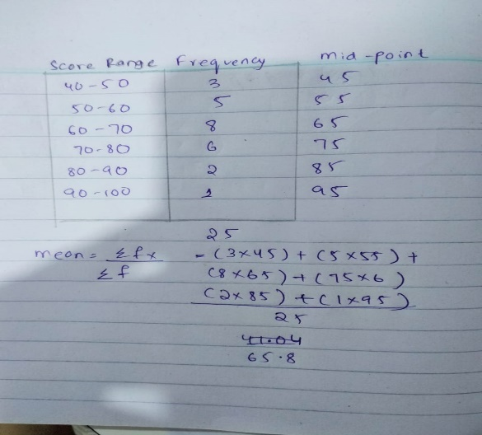**Q1.**On a final exam, a lecturer noted each student’s score. This frequency distribution is the grouping of the scores:

| **Score Range** | **Frequency** |
| --- | --- |
| 40-50 | 3 |
| 50-60 | 5 |
| 60-70 | 8 |
| 70-80 | 6 |
| 80-90 | 2 |
| 90-100 | 1 |

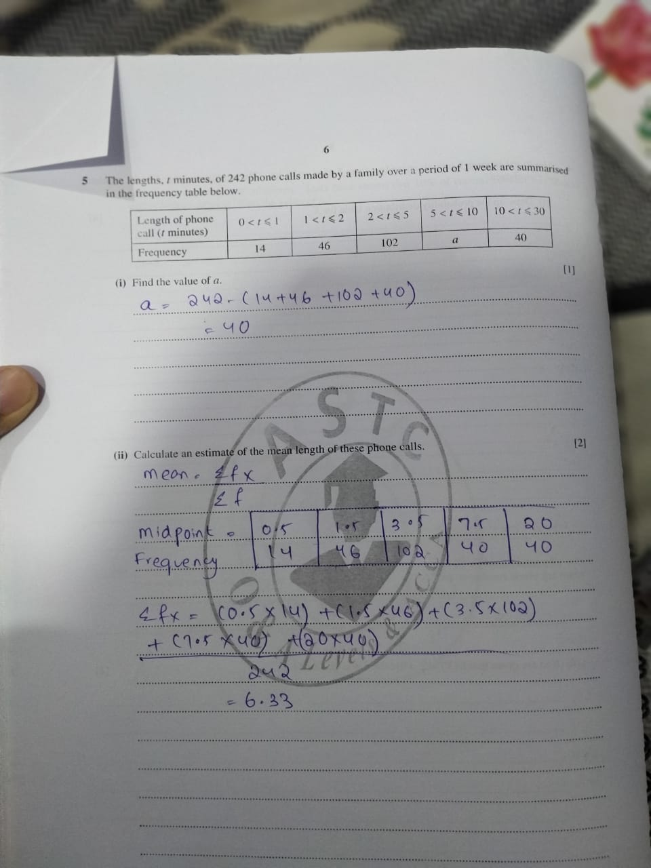

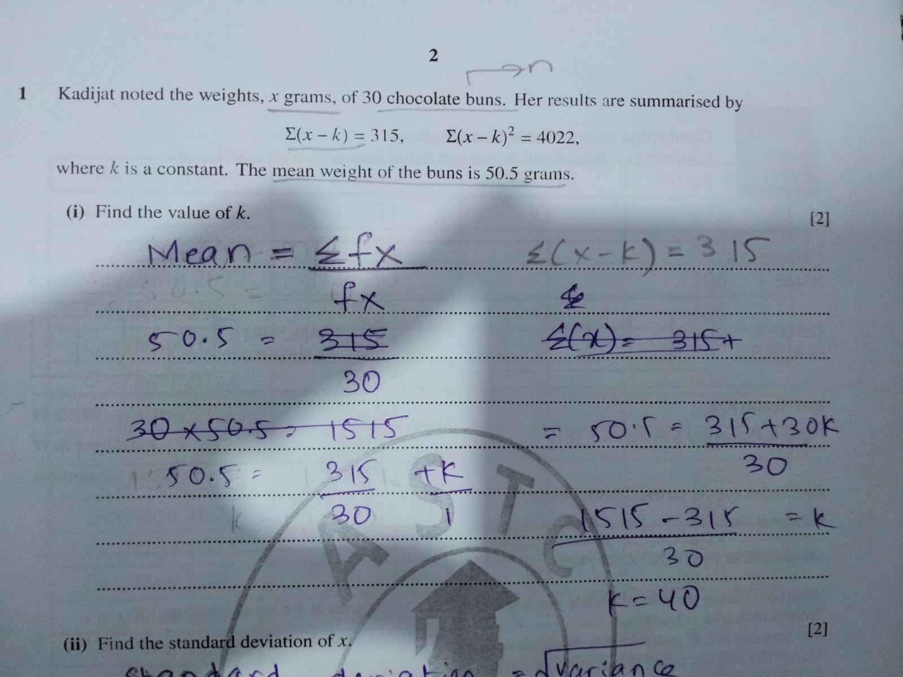

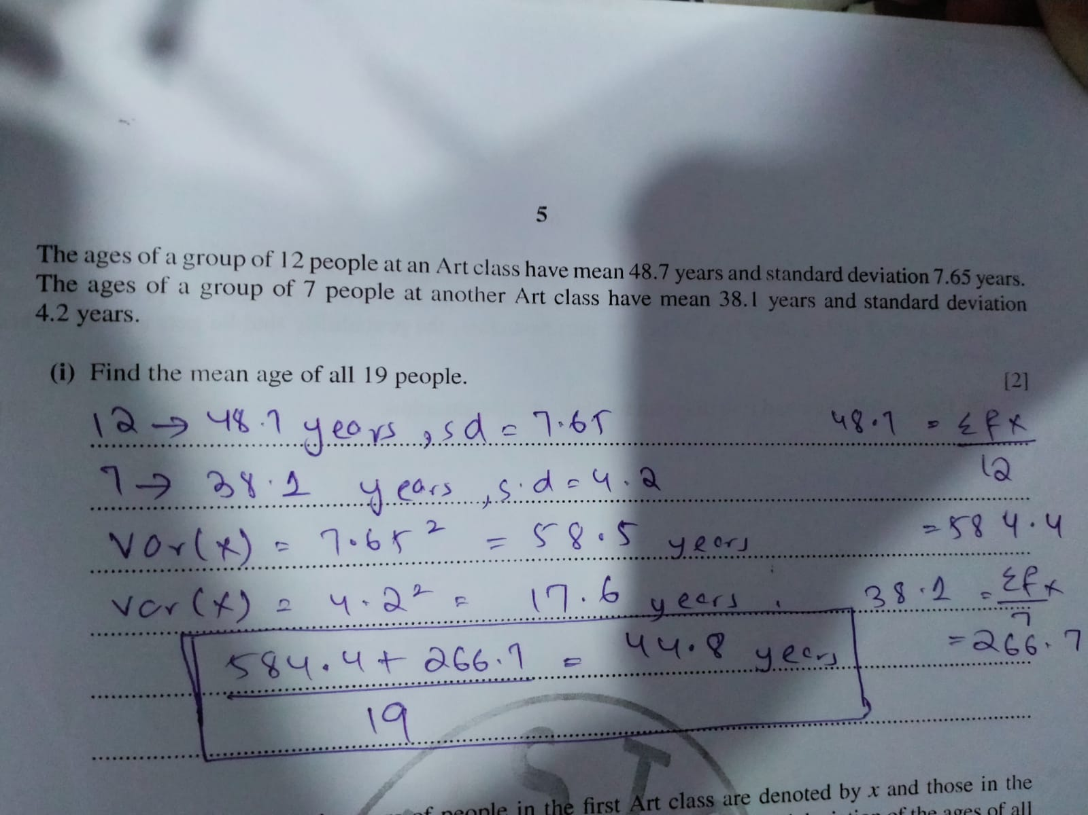

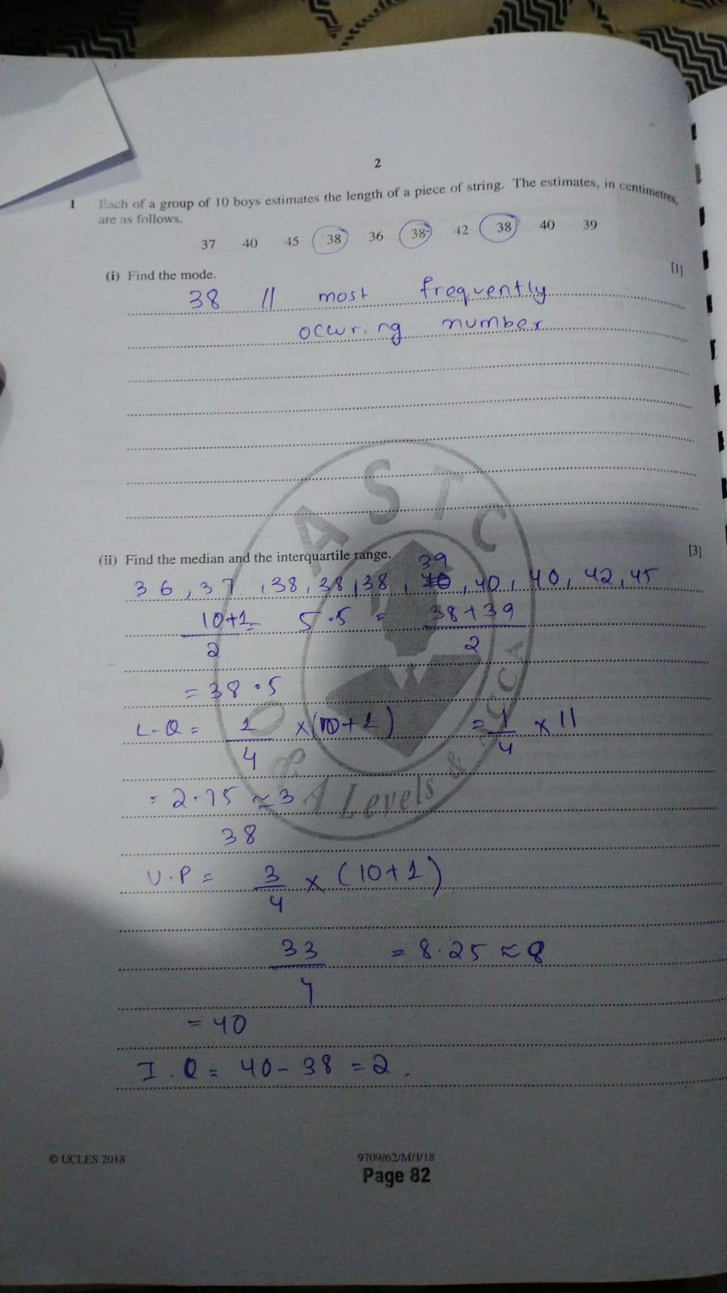

Binomial Distribution:  
A random variable X is a binomial variable if the following conditions are satisfied:

1. Each trial is independent of the others.

2. There is a fixed number of trials.

3. The outcome of each trial can be classified as either success or

failure.

4. The probability of success stays constant over each trial.

P(X = x) = nCx p^x q^(n-x)  
**https://lh7-us.googleusercontent.com/docsz/AD_4nXfqH9lBPQ88jCw2uPJi6ulsrwzQxS1Uj6rnrVKgc1boWZ2n9dwdYi6v50dEhJKClFNgQd3N7BZMYxyGshBXX7_VSGvHMS61OMfYHYfg63lvYe_9DDwxUrHLfBh-26vIoakx8iOne9iqvXajZfdHLu9W4YU?key=hGFrS7A5ap30trhwVVmPlQ**

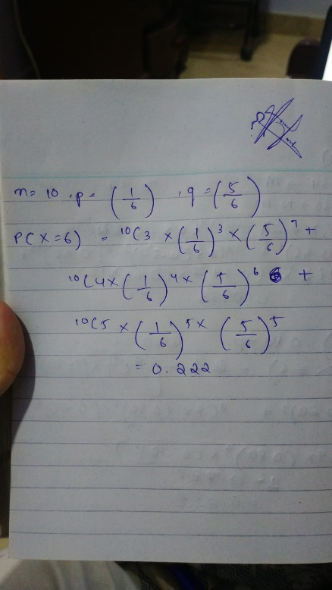

**https://lh7-us.googleusercontent.com/docsz/AD_4nXc_yp41hOZ9LwRSp_LE0YXAwNFs0dlEktBeVMEIffLu7v13n-iwbGfurz7aGXQXowvsNTUufaopO074cCpKkpwZmUCbuq4Rk6vCUZ1ZflaobXu3u77kwJMWmNgrRo-Gy1cDYB8mEktnQkl5vfTllblxxxM?key=hGFrS7A5ap30trhwVVmPlQ**

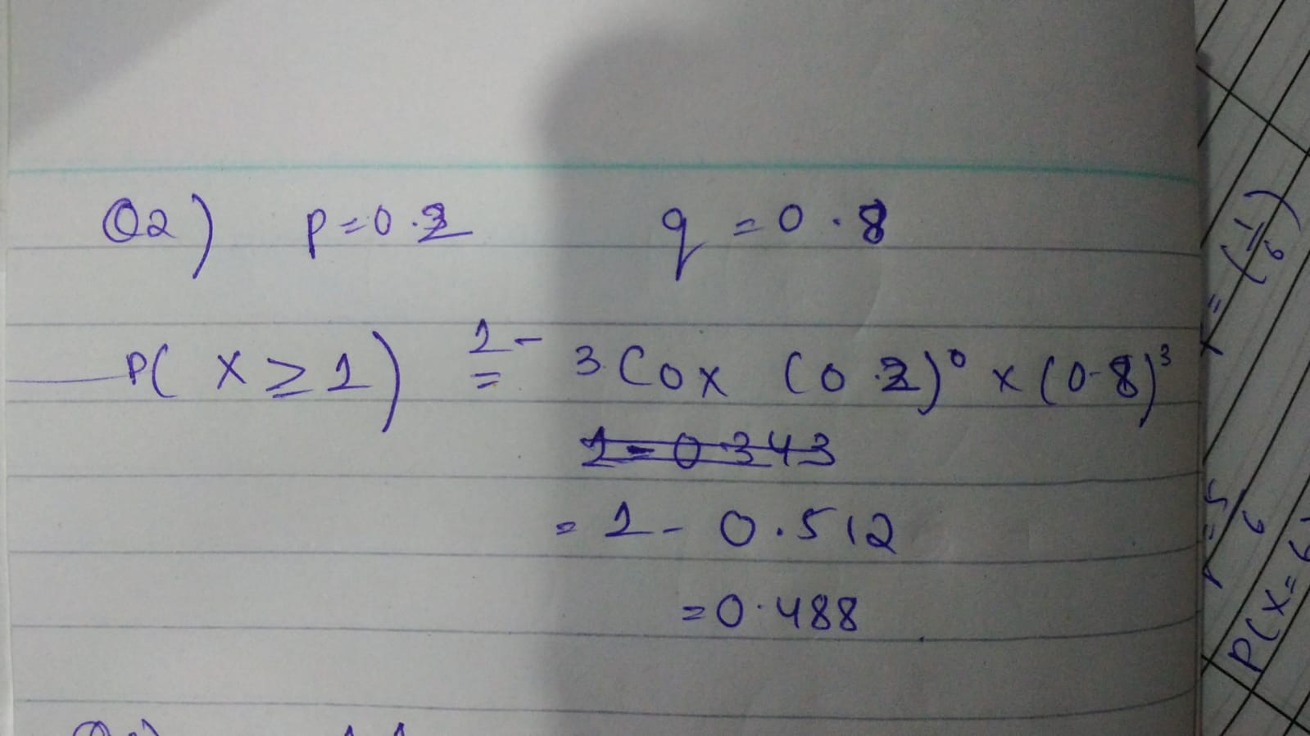

**https://lh7-us.googleusercontent.com/docsz/AD_4nXfJJAjfyukUNAZ5ix2dRn-qyDYXuQBvB3GzPToJI5N8x1YMbbBqKckcsEtoNw5vo1TcYEIeEZg4UWuC1WSJFmXo0EPpeEGu9zZZU1YwvaD0HOASy1v_SF9D_14FcCR77DuffAfYhXSG4OBaXQgSO44Wjhhy?key=hGFrS7A5ap30trhwVVmPlQ**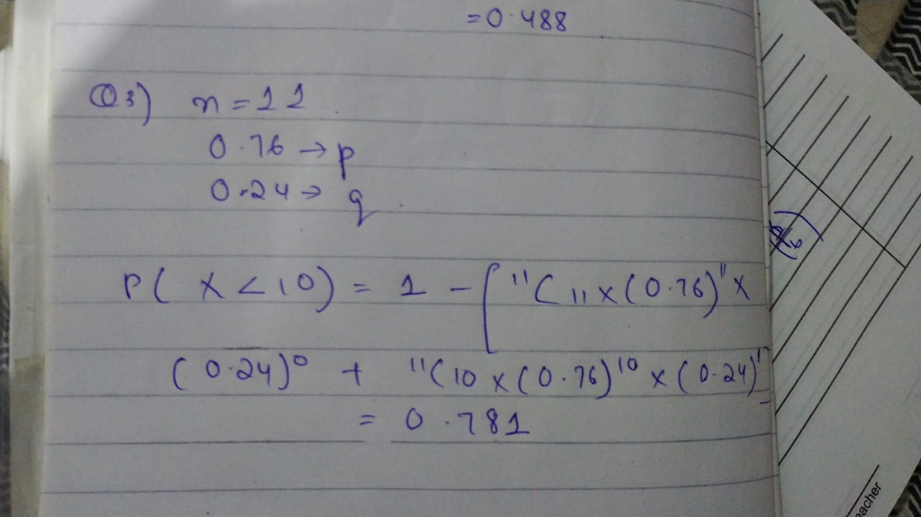

**https://lh7-us.googleusercontent.com/docsz/AD_4nXeW2D0R10N2HhWHEBnB92Nv4X10V0j61SVsOEf3zGmA0Hs1tvYeAf4dgu5mjomSWvskvVgyBeRFTi0emC5Hv1lb8kP08GaduIw5PdqLL376_wBXRcvWTaA6obMcGm0azqQB4uwBociwScgqbx1pJmupC3KU?key=hGFrS7A5ap30trhwVVmPlQ**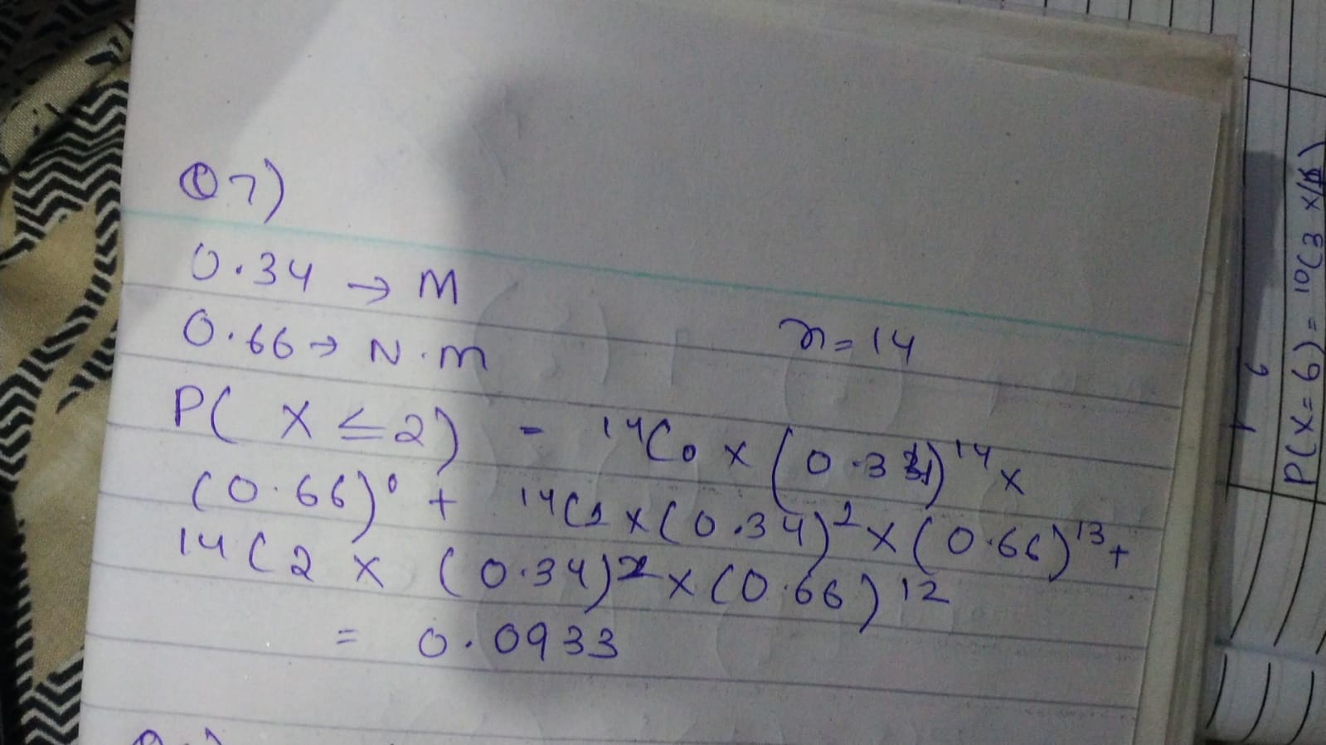

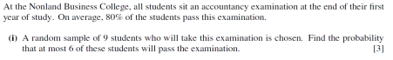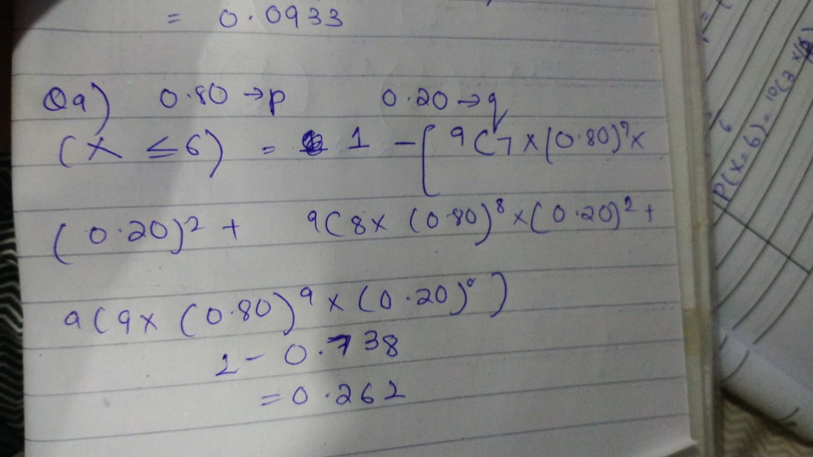

NORMAL DISTRIBUTION:

Used MF19 (ALEVELS S1) table or values of z

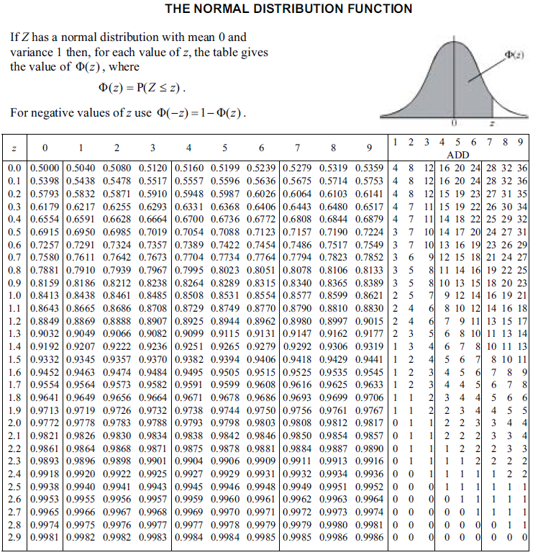

**https://lh7-us.googleusercontent.com/docsz/AD_4nXcakU9tMr4PUvyIzL_gTosvwSqoGnjXAqIl68KDo21OGohs3r8S89oyMnI9Of_htAQqYCSRac_FKWggpeTYw6x4W7N613VjQJ7QC4tMWDCc006ZvDLro8Uu5wewp3nX1ipWcWSoSbssoZCzKjgtKgxWJNU?key=uzA7zRG-AECaaBr9bTMQEA**

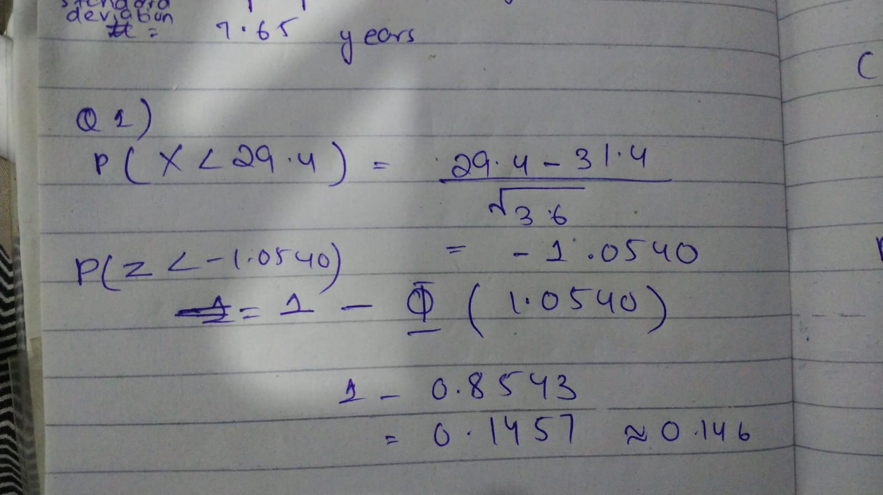

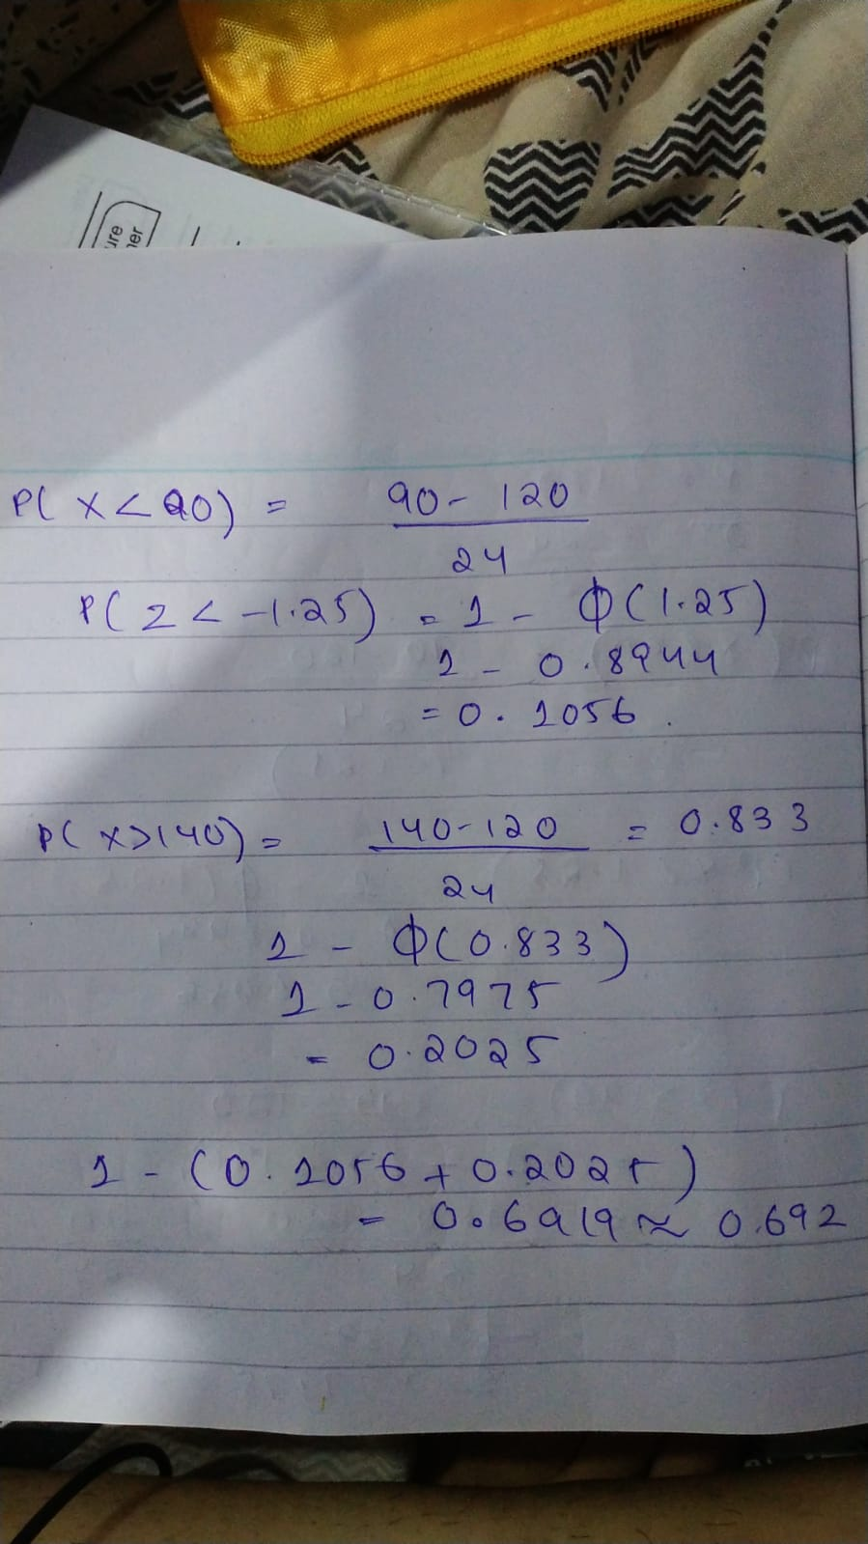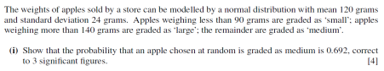

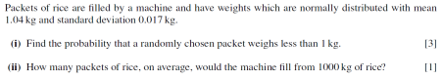

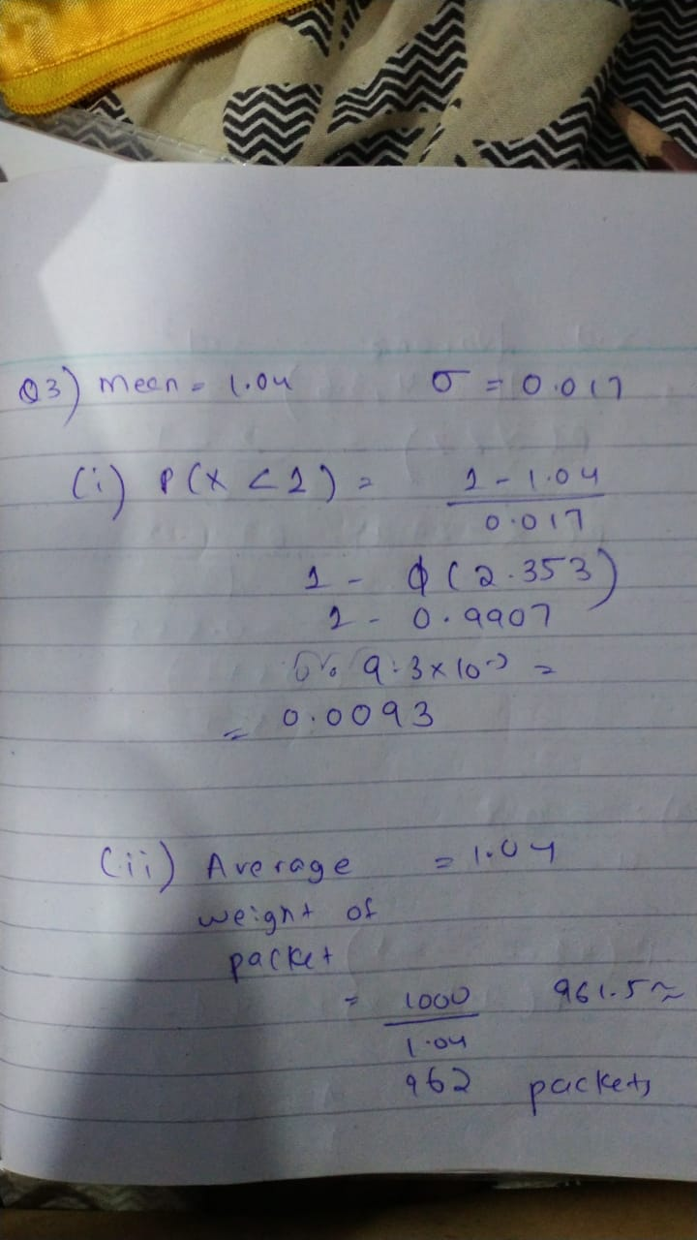

**https://lh7-us.googleusercontent.com/docsz/AD_4nXd-cFyziVwQe7LqjtJwuAxeVMGJavXn-5dHJd13Y821jTPuSYjhsLTQUigjIUvlA-FTnS8Tunyps-4k7xY61mBWCdGADWNJXwonqFw08TWcgmaAJrnRv4xwTojiS2tc7OYB0BZ8hCiwv-5xK2R1GBcmhrLK?key=uzA7zRG-AECaaBr9bTMQEA**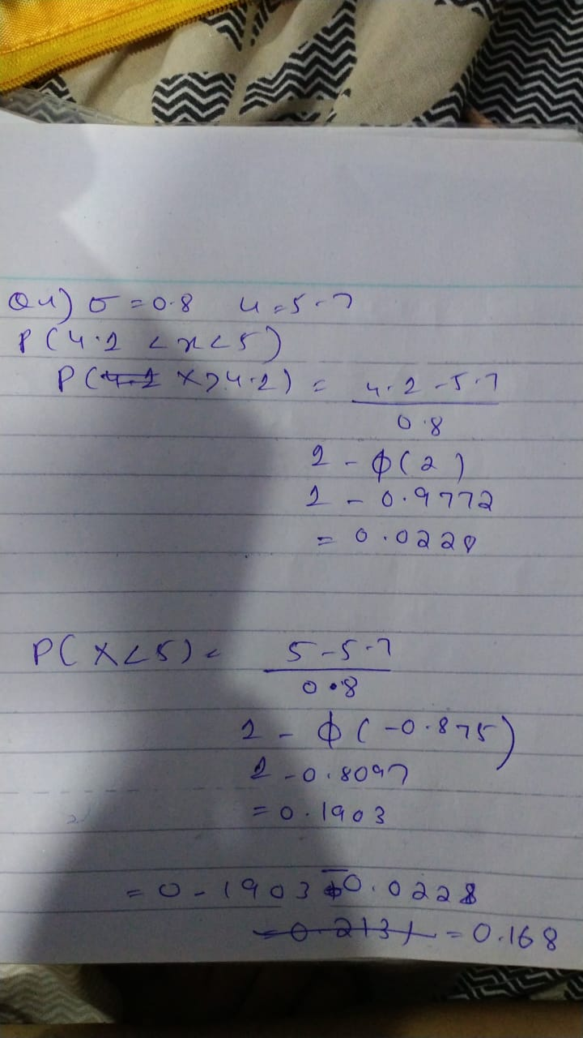

PROBABILITY:

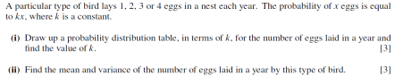

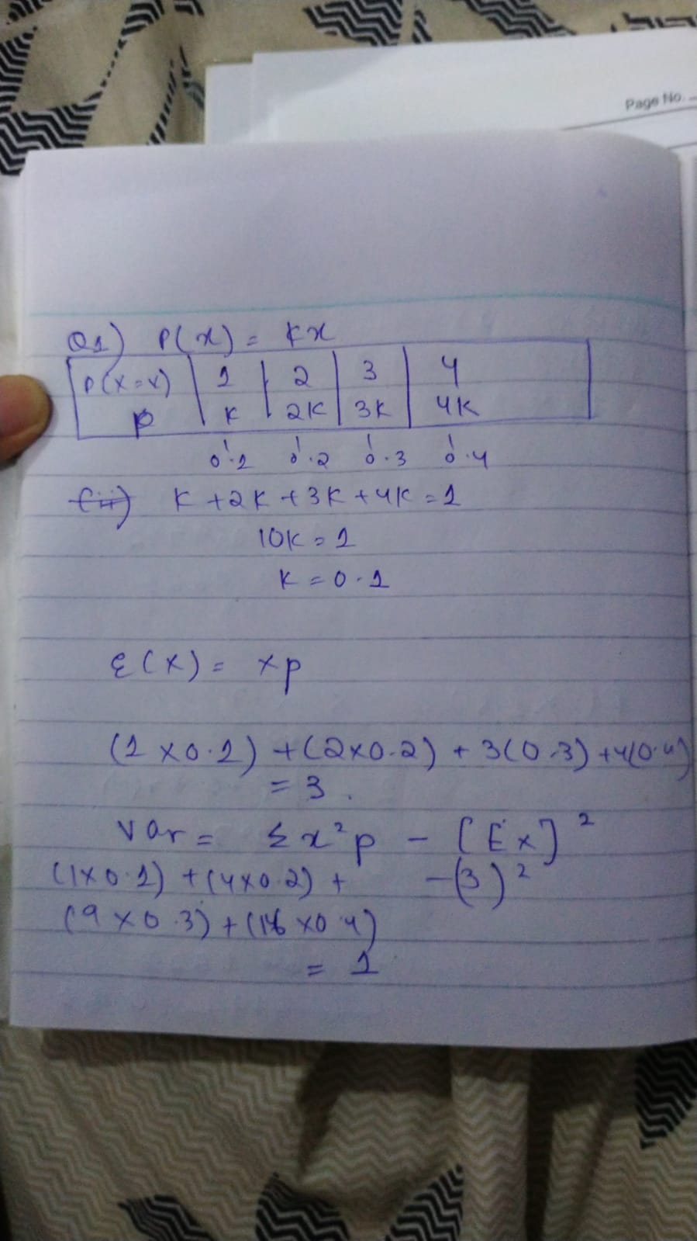

**https://lh7-us.googleusercontent.com/docsz/AD_4nXfYgX9DbEGz6_gCe4Z_KpfDKDSew0fHXLGed7pFcp2VawUMf1mcCZFyFggXGdLoAwXJaDzZPMuZtEm2AmkIMZPyzwOdxPOeNHgO72rIin-qrqDGVOITxHWnRSL4uCfqAbbCKdED4MfUm-Fa6Bzrc_NKZ1Ux?key=KbwFzjMGPZjMI5qGGKHXtw**

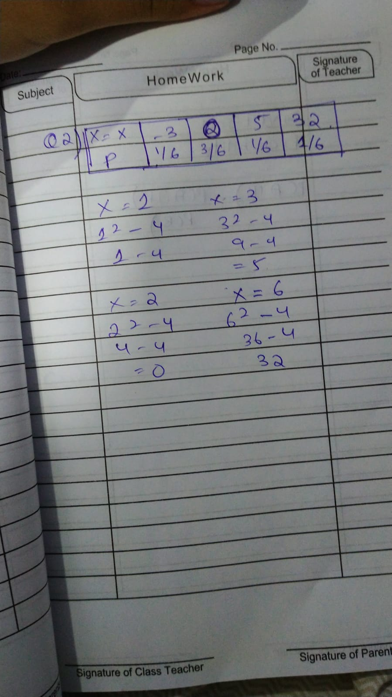

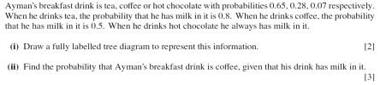

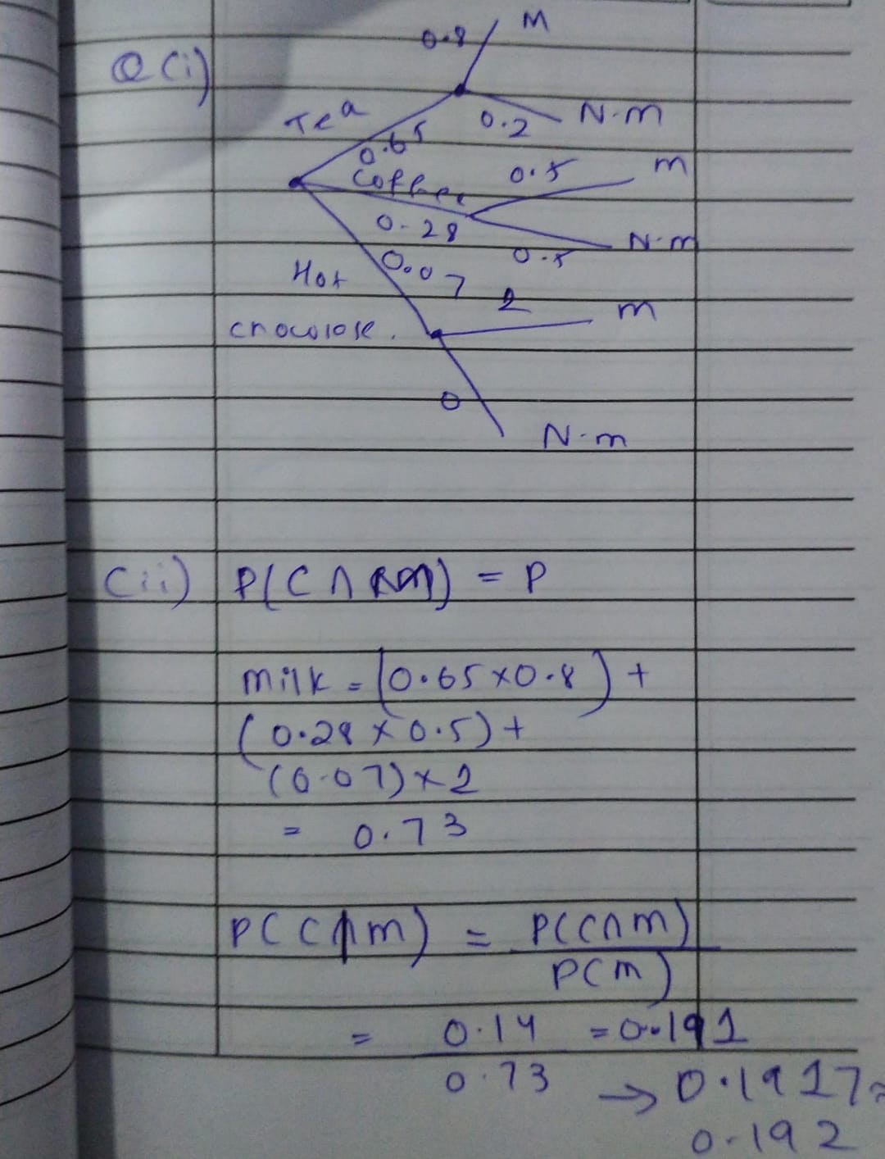

**https://lh7-us.googleusercontent.com/docsz/AD_4nXenVb3xXa7Bib49pkPk6EhCCPEdaeLfVP0H7K4rpOJJ6k0mBygyWMMnhXKqmQBw8G-q_tmTeoGkA935XDrGwa-duoAUTpcjVoFeFBdeUkbTluU-sn-kldS5KXm9USOk38PNB-7-30PnrHuWcYDELLv4Q2o?key=xL0vpk5Ez-j0-nZpIgh2ng**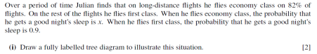

**https://lh7-us.googleusercontent.com/docsz/AD_4nXeIXt36AR_Rt-gNP3O6PywYe9aopJg0mEtYEytR_BH-8UKC-R9youNrHvSodj5ixZ-18yFx58DTw7mhwFkPjdRaMruPQqeO5CjVgLHAcMX7RMp9q3QHZrOME2Bm4jC7gCBj7zyoXdG27Wd3ASCl-UBk01ht?key=xL0vpk5Ez-j0-nZpIgh2ng**

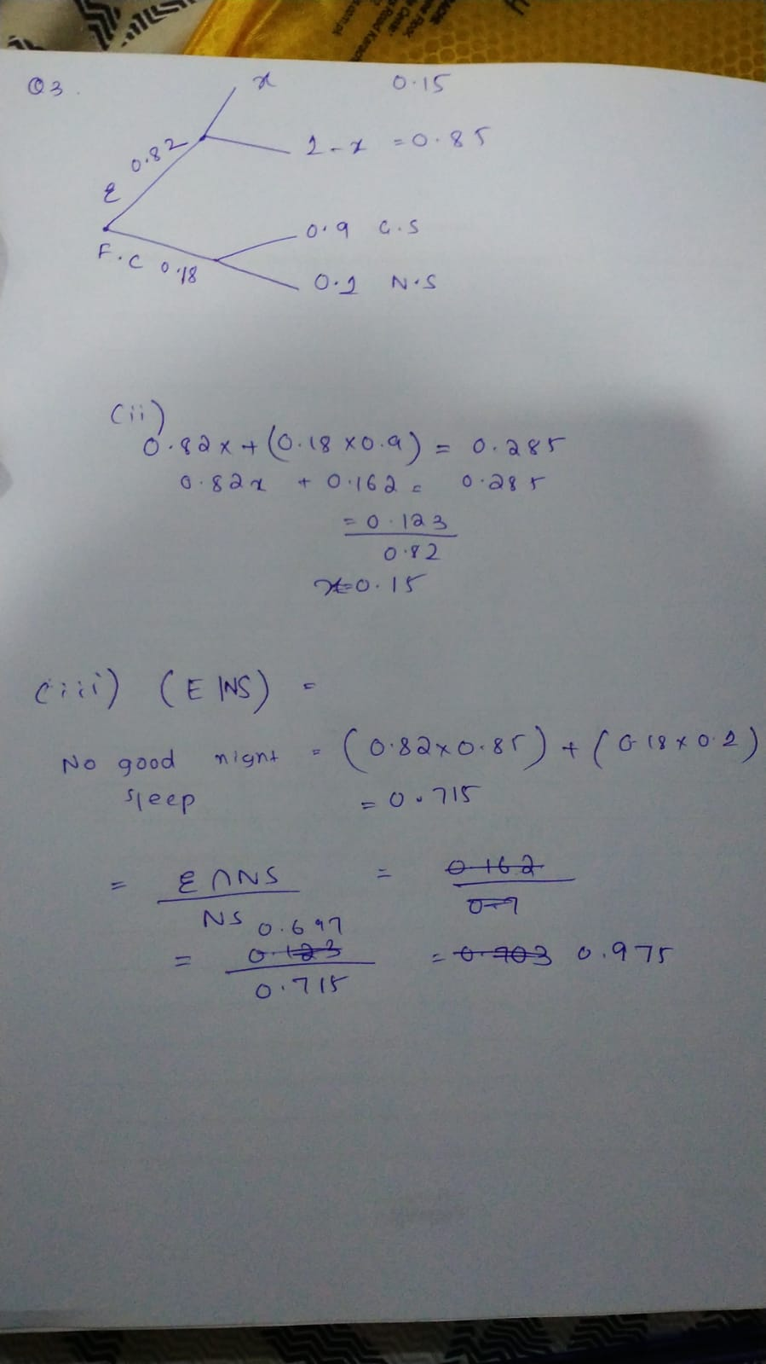

POISSON DISTRIBUTION

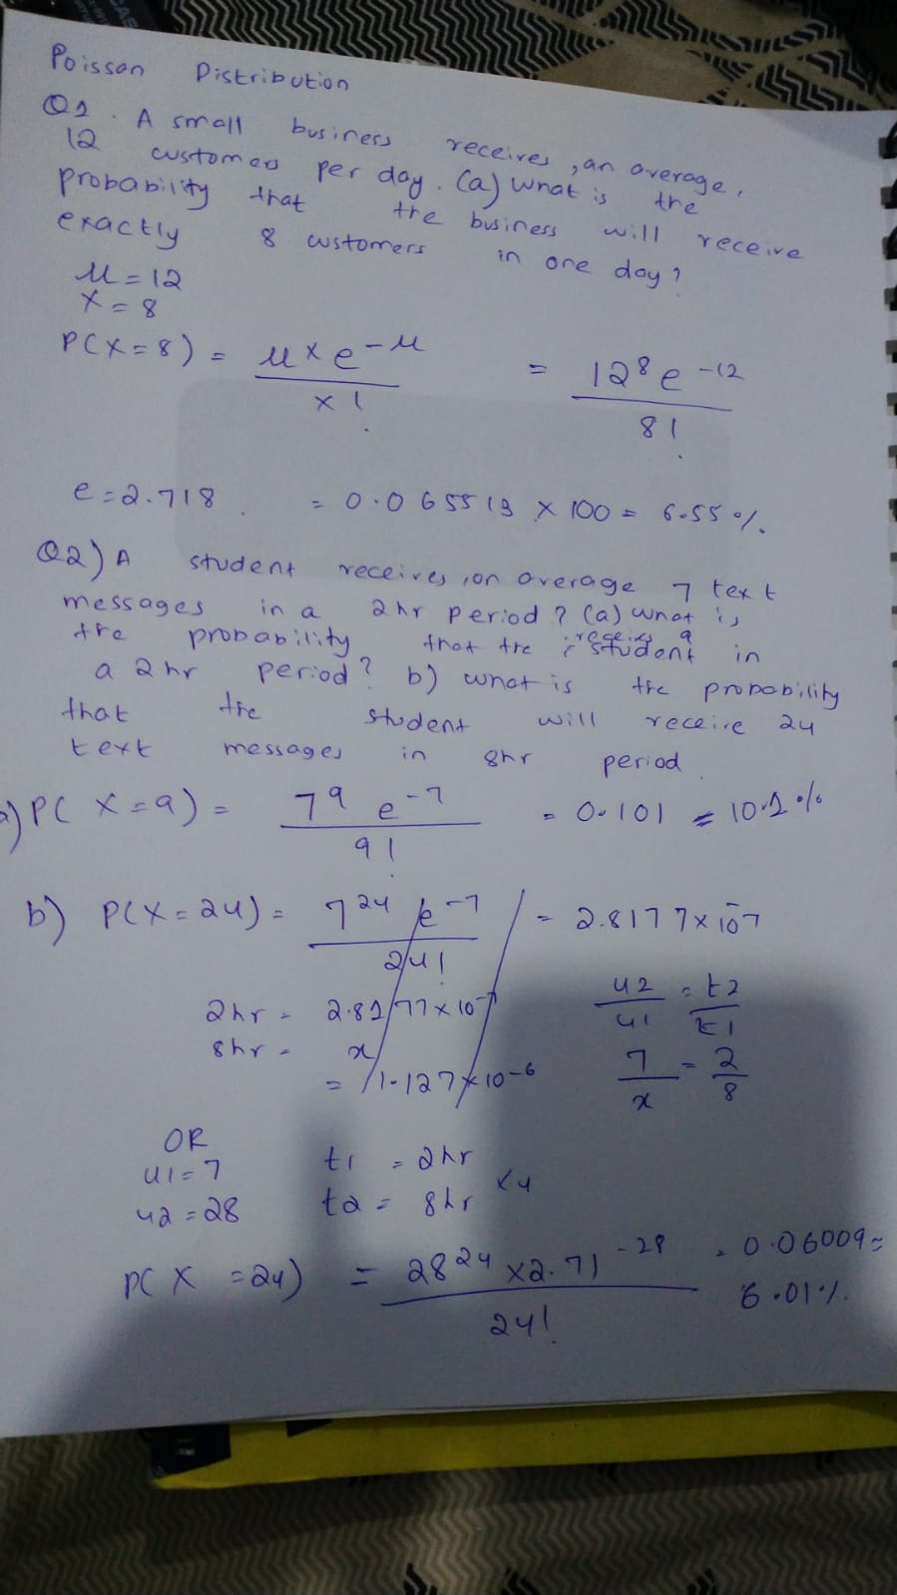

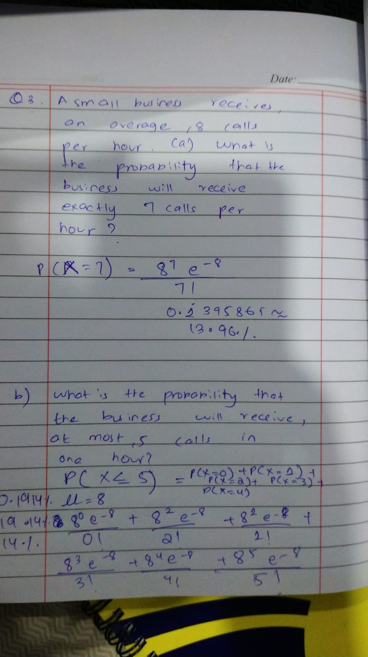

UNIFORM DISTRIBUTION

